COLLEGE MANAGEMENT SYSTEM

**Acknowledgement****s**

**Abstract**

This project work automates school management system. In the system two applications are developed, Windows based (thick client) and Web based (thin client).

The windows application takes most of the activities such as offline student registering, transcript and report card generation and producing the timetable. The web application facilitates attendance recording by the homeroom teachers, to view status of students by their parents and to view reports by kebele and kifle-ketema education bureau officials.

Our solution of the timetable is very simple. In the high school considered for the project there are ten subjects for both grade nine and grade ten. Loads are assigned to each subject teacher and a code is given for each teacher-subject combination. A simple search technique has been used during allocation of each teacher-subject code to a time slot. A database has been used to enforce constraints and to store data.

The prototype has been tested with data from Kokebe Tsebah Secondary School. It has been observed that the system successfully registers students, facilitates attendance recording by the home room teachers and generates various reports such as report card, transcript and a feasible timetable satisfying the constraints (requirements). It has also been shown that the system facilitates to view the status of students by their parents using the Internet or Intranet of the college.

**Chapter 1**

**Introduction**

**1.1 Background**

Education system forms the backbone of every nation. And hence it is important to provide a strong educational foundation to the young generation to ensure the development of open-minded global citizens securing the future for everyone. Advanced technology available today can play a crucial role in streamlining education-related processes to promote solidarity among students, teachers, parents and the school staff.

Education is central to development. It is one of the most powerful instruments for reducing poverty and inequality and lays a foundation for sustained economic growth. With this aim currently our government has given special emphasis to the educational sector and school improvement activities such as continuous professional development for teachers, training and upgrading teachers and capacitating schools with manpower and materials are among the major actions which have been taken in both primary and secondary schools. In order to facilitate and simplify these actions one of the major tool is to have automated school management system.

School Management System(SMS) consists of tasks such as registering students, attendance record keeping to control absentees, producing report cards, producing official transcript, preparing timetable and producing different reports for teachers, parents, officials from kebele or kefle ketema education bureaus and other stakeholders.

Automation is the utilization of technology to replace human with a machine that can perform more quickly and more continuously [2]. By automating SMS documents that took up many large storage rooms can be stored on few disks. Transcript images can be annotated. It reduces the time to retrieve old transcripts from hours to seconds. However, the school system in the government schools of Addis Ababa is not automated and the record officers generate transcripts and reports manually and the school administrators use their experienced knowledge of miss and hit approaches to prepare timetables.

**1.2 Statement of the Problem**

To help promote students achievement and success, schools must have access to complete, accurate, and timely information about students. One of the benefits of automated SMS is that the student record system will simplify retrieval of required information and is a great instrument for school improvement by taking measures from the information acquired. Despite the use of automated SMS, the government schools in Addis Ababa are using paper based documentation system for performing various tasks and the school administrators apply their knowledge of hit and miss approach in scheduling classes and courses (preparing the timetable) which wastes manpower and much time unnecessarily that does not utilize the current technology.

Transcripts of students are prepared manually by the record officer and teachers. Report cards are produced by the home-room teachers. Attendance of students is recorded by the home-room teachers. In order to control absentees and know the number of days that a student has been absent from the school during the school days the attendance officer has to collect the attendance slips from the corresponding homeroom teachers and compile it which is also a time taking process. In addition to that retrieving records of students who have graduated couple of years ago has been a difficult task and the manual system also has difficulty of producing different reports which are required by the stakeholders such as teachers, administrators or officials from kebele and kifle-ketema.

Teachers may want to associate a student with his parent or emergency persons for disciplinary measures which need searching of the students record in the record office. It has been difficult to search a record from thousands of such records and observed that students can take any person claiming that he/she is their parent or emergency person which creates problem in control of students.

Due to the inefficiency of the current manual system, the need arises to automate SMS in order to efficiently handle students’ attendance, to produce transcript, report cards and the various reports satisfying users and customers and to produce timetable which can schedule courses for teachers and classes of students.

**1.3 Objective**

The general and specific objectives of the project are described below:

**1.3.1 General Objective**

The general objective of the project is to automate the SMS.

**1.3.2 Specific Objectives**

In order to attain the general objective, the following list of specific objectives is set:

To develop an offline registration system, To facilitate attendance record keeping, To facilitate various report generation,

To allow teachers, parents, school community and Education bureau officials to view reports on students,

To produce a timetable

**1.4 Organization of the Document**

This report document contains seven chapters including this chapter. Chapter two defines and describes concepts with regard to SMS, aiming to give a general view to the reader of the document about tasks or activities which need automation in the school environment. Chapter three presents review of research works on SMS. In chapters four and five, we presented the analysis and design of the developed system respectively. In the remaining chapters, prototype development and conclusion and recommendations are briefly explained.

**Chapter 2**

**Overview of the** **College Management System**

This project emphasizes on school management system in Ethiopian secondary schools.

Therefore, we give an overview of the management system of secondary schools in Ethiopia.

**2.1 Secondary College in Bangladesh**

Secondary education follows eight years of primary education and is for children aged 14 and above.

At the beginning of each academic year which starts in September (Ethiopian New Year), the students get registered and assigned rooms. Each class (section) of students is assigned to a fixed room. Home room teachers are assigned to each class of students. There are two semesters per year. The first semester final examination is usually administered during January, the second semester final examination is administered during the end of June and consequently the results of each class of students is collected, organized, ranked by the corresponding home room teacher and reported to each student. The homeroom teacher also records attendance of each student on each school day which is later organized by the attendance officer. A student who has been absent for more than twenty days is not allowed to take a semester final examination and will be forced to withdraw.

Transcripts are generated by the record officer. A student may request transcript when he/she wants to transfer to other school or when he/she has completed/graduated from the school and needs to join higher education or for some other purpose.

Officials from kebele and kifle-ketema education bureaus want to get statistical reports like number of registered students at the beginning of every year, number of drop outs, and number of passes/failures for each subject at the end of each semester as well as number of passes/failures at a grade level to help them participate in decision making.

**Chapter 3**

**Literature Review**

Automated SMS plays a great role in simplifying the job of employees at the school and satisfying the need of customers and stakeholders of the school. Even though no documentation is found in Ethiopia to be reviewed, products have been observed at some schools to help understand the problem of managing schools and handling school data. This chapter reviews these products.

**3.1 Observed Products**

In the year 2019 City Government of Bangladesh was very much interested to have automated school management system to get uniform and quick access to the students’ data for administrative purpose on promoting the students’ achievement and related issues. The bureau has selected Wundrad Preparatory School for pilot test. At the time the school principals together with officials from CGAAEB signed a contractual agreement with some software developer company. The developers installed their first version of the product which can register a student offline and generate official transcript with some level of difficulty. As the system is not fully automated, it does not support management of attendance, does not support generating report cards and other important functions such as generating school timetable and a web based report for parents. Due to the lack of follow up by the government officials at, the company was unable to complete the project. The school currently is unable to use the partially developed system because of lack of trained person and lack of hardware and software maintenance.

Another product that is in use is transcript generator system. The transcript generator system at Menelik II Preparatory School generates official transcript of students. In order to generate transcript the record officer enters the student information along with the grade marks for the grades completed per year and per semester. Then the system generates the required official transcript. Currently the school is using the system to generate official transcript even though the data entry format has unnecessarily many fields which are not applicable for the record office but can be used for continuous assessment by the course teacher.

- 9 -

**3.2 Manual Timetabling**

Manual timetables are prepared by dedicated teachers. In manual timetabling, it is common to proceed in an iterative fashion where each iteration selects and schedules a lesson [3]. Scheduling a lesson requires to choose a classroom (fixed for each section of students) and a time slot such that the commitment to the choice will not violate any constraint.

In school timetabling, we are required to schedule a given set of meetings such that the resulting timetables are feasible and acceptable to all people involved. Humans are able to prepare the timetable using some hit/miss approach. So it is possible to automate the timetable based on a simulation of the human way of solving the problem. Such techniques, that we call direct heuristics, were based on a successive augmentation. That is, a partial timetable is extended, lecture by lecture, until all lectures have been scheduled. The underlying idea of all approaches is to schedule the most constrained lecture first.

Usually some responsible teachers are assigned to schedule subjects and teachers. The number of teachers available per each subject is predefined and the load that each teacher has is calculated. With these data the timetable constructor assigns each teacher-subject association to the appropriate classes with the available time slots.

The manual solution of the timetabling problem usually requires many person-days of work. In addition, the solution obtained may be unsatisfactory. The lessons should be fairly distributed satisfying the identified constraints.

**3.3** **Drawbacks of the Reviewed Systems**

The reviews described have the following problems:

* Generate official transcript with some level of difficulty,
* Do not sufficiently produce the required reports to allow parents to view status of their children and reports for officials of kebele and kifle-ketema to help them participate in decision making,
* Do not generate timetable for the schools
* Do not facilitate attendance record keeping by the homeroom teachers

This project work tries to fill the gap by automating the various activities at schools. It tries to satisfy customers need and simplify the works of administrators, record officer and teachers. With an automated school management system parents can easily interact with the school community to follow up their children’s achievement and play their role in the school development processes.

**Chapter 4**

**System Analysis**

In this chapter the functional and non-functional requirements of the system are described and modeled using UML models.

**4.1** **Functional Requirements**

The functional requirements of the system are:

* register a student,
* record attendance of students,
* generate various reports,

**4.2 Non Functional Requirements**

Security requirements are important factors in this system as classified data will be stored in the database. User validation will be done during login to insure that the user is valid and that the user only has access to his or her permission data. General users will only have access through the user interface.

The system will have consistent interface formats and button sets for all forms in the application, will have a form based interface for all data entry and viewing formats, and will generate reports that are formatted in a table and that should look like the existing manual report formats for user friendliness.

The system will be easily maintained by the developer or other authorized trained person and it shall respond as fast as possible in generating report and producing the timetable.

**4.3 Analysis Model**

To produce a model of the system which is correct, complete and consistent we need to construct the analysis model which focuses on structuring and formalizing the requirements of the system. Analysis model contains three models: functional, object and dynamic models. The functional model can be described by use case diagrams. Class diagrams describe the object model. Dynamic model can also be described in terms of sequence, state chart and activity diagrams. For the purpose of this project we have described the analysis model in terms of the functional model and dynamic models using use case and sequence diagrams

**4.3.1 Actor Description**

**Name: Super Admin**

**Description:** A super admin is holding all the power.

**Name: Teacher**

**Description:** A Teacher is a teacher assigned by the school director to each class ofstudents to follow the students closely. He/She has the responsibility of recording attendance of students and submitting.

**Name: Librarian**

**Description: Librarian is holding the power of performing any book related issue****.**

**Chapter 5**

**System Design**

In the previous chapter we have identified the functional and non-functional requirements of the system and produced the analysis model. The following are discussed in this chapter: design goals, system architecture, system decomposition, deployment and database design.

**5.1** **Design Goals**

Design goals describe the qualities of the system that developers should optimize. Such goals are normally derived from the non-functional requirements of the system.

Design goals are grouped into five categories. These are

* Performance
* Dependability
* Maintenance
* End User Criteria

**5.1.1 Performance Criteria**

The part of the system to be used for the record office should have a fast response time (real time) with maximum throughput. Furthermore, the system should not be taking up too much space in memory. The record officer has chosen fast response time over throughput and hence the system should try to be more interactive. In the case of the timetabling subsystem, the system should be more reliable in order to satisfy the constraints than fast response time.

**5.1.2 Dependability**

The school needs the system to be highly dependable as it is expected to be used by non-IT professionals. The system should be robust and fault tolerant. Furthermore, as the system is handling sensitive data of the school, high emphasis should be given with regards to security, as there are subsystems to be accessed through web.

**5.1.3 Maintenance**

The system should be easily extensible to add new functionalities at a later stage. It should also be easily modifiable to make changes to the features and functionalities.

**5.1.4 End User Criteria**

**Usability:** Usability is the extent to which a product can be used by specified users toachieve specified goals with effectiveness, efficiency and satisfaction in a specified context of use. From the end users’ perspective the system should be designed in such a way that it is easy to learn and use, efficient and having few errors if any.

Trade-off is inevitable in trying to achieve a particular design goal. One best case is the issue of security versus response time. Checking User-Id and Password before a member can enter to the SMS creates response time problem/overhead. The other case is the issue of response time versus quality. There is some amount of time taken by the system to generate the timetable. So the user has to wait a little after telling the system to generate the timetable and getting the result to get a quality timetable.

**5.2** **Architecture of the System**

The proposed system is expected to replace the existing manual system by an automated system in all facets. It is mainly based on the system Analysis document (chapter 4).

The architecture used for the system is a 3 tier Client/Server Architecture where a client can use Internet browsers to access the online report provided by the system within the local area network of the school or any where using the Internet. Figure 5.1 shows the architecture of the proposed system.

The data tier maintains the applications data such as student data, teacher data, timetable data etc. It stores these data in a relational database management system (RDBMS).

The middle tier (web/application server) implements the business logic, controller logic and presentation logic to control the interaction between the application’s clients and data. The controller logic processes client requests such as requests to view student’s result, to record attendance or to retrieve data from the database. Business rules enforced by the business logic dictate how clients can and cannot access application data and how applications process data.

A web server is a program that runs on a network server (computer) to respond to HTTP requests. The most commonly used web servers are Internet Information Server (IIS) and Apache. The web server used in this system is IIS. HTTP is used to transfer data across an Intranet or the Internet. It is the standard protocol for moving data across the internet.

The client tier is the applications user interface containing data entry forms and client side applications. It displays data to the user. Users interact directly with the application through user interface. The client tier interacts with the web/application server to make requests and to retrieve data from the database. It then displays to the user the data retrieved from the server.

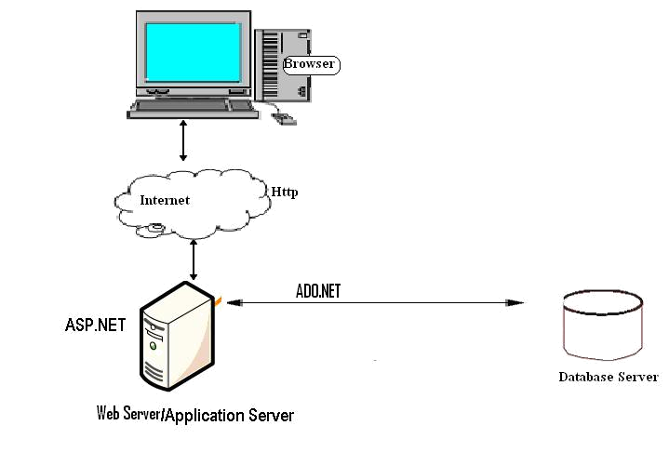

**Figure 5.1 Architecture of the System**

**5.3 Subsystem Decomposition**

Subsystem decompositions will help reduce the complexity of the system. The subsystems can be considered as packages holding related classes/objects. The SMS under consideration is decomposed into subsystems as shown in Figure 5.2. These subsystems are further decomposed into other subsystems. The major subsystems identified are “StudentRegistration”, “Login”, “Attendance”, “ReportCard”, “Transcript”, “Timetable” and “Report” subsystems.

Users are classified in to roles. The “Login” subsystem authenticates a user to grant access based on the role of the user. The “StudentRegistration” subsystem registers a

student offline. It allows recording the detail information of the student including parental and emergency person.

“Transcript” and “ReportCard” subsystems are used to generate transcript and report card respectively. The “Timetable” subsystem generates a timetable, which involves allocating a time slot to a subject teacher for a class of students.

The “Attendance” subsystem facilitates recording absent students on the school day by the homeroom teacher to control absentees and to report to parents and the administrator to take corrective measures. The “Report” subsystem generates reports to parents, officials from kebeles and kifle-ketema and teachers in order to facilitate viewing students’ status and course achievement online.

5.4 Hardware/Software Mapping

One of the major tasks in system design deals with hardware/software mapping which deals with which components would be part in which hardware and so on. The SMS is a broad system that performs many functions as described in chapter 4. It consists of web based system used by homeroom teachers to record attendance. The web based system also assists parents and officials to get or view status and report on students’ achievement and progress. The system assists the record officer to generate transcript and report cards. So the web based part is expected to run on a networked environment on different Operating System platforms. The client/server architecture of the system enables different clients to connect to the server remotely through Internet connection.

The system has two nodes such as the ***Web server*** and ***Clients.*** These nodes are shown as UML Deployment diagrams in Figure 5.4. The nodes can represent specific instances (workstations) or a class of computers (web server), which is a virtual machine. The applications of the system will run on the web server connected to the database server by ado.net. The system has two applications to be developed on the same database, Windows and Web applications. When dealing with windows applications, there are compiled program that must be distributed to the users desktop before they can use it. Depending on the application, there may also be one or more supporting DLLs or other executables such as Crystal Reports [6]. While in thin-client applications (Web applications) there is typically no program or DLL to be distributed.

**5.5 Persistent Data Management**

Persistent data management deals with how the persistent data (file, database, etc) are stored and managed and it outlives a single execution of the system. Information related to student basic information, student’s attendance and grade mark, the timetable produced and other related information are persistent data and hence stored on a database management system. This allows all the programs that operate on the SMS data to do consistently. Moreover, storing data in a database enables the system to perform complex queries on a large data set

The schools register students every year in thousands per grade level. For complex queries over attributes and large dataset Microsoft SQL Server is implemented, which is a Relational Database Management System.

**5.5.1 Mapping**

In order to store information persistently we map objects into tables and the attributes into fields to the specific table based on the objects found on the system. Therefore, we identified the major tables that will be implemented on the selected DBMS. For this reason, some of the mapping of objects to tables is displayed as in Fig 5.5.

**5.5.2 Relationships among Tables**

This part is to describe and show the necessary relationships among the tables, which are selected to store the data persistently in the system. Generally there are three types of relationships in a relational database system. These are one-to-one, one-to-many and many-to-many relationships. The system under consideration has one-to-many and many-to-many relationships.

Student and AcademicSubject tables have many-to-many relationships. One of the aims in a database system is to reduce redundancy and for that purpose many-to-many relationship has to

be reduced to one-to-one relationship. The Student and StudMarks and the AcademicSubject and StudMarks have one-to-many relationship by using the StudMarks table as the associate table. The relationship of the remaining tables and the ones described here are descriptively shown in following figure.

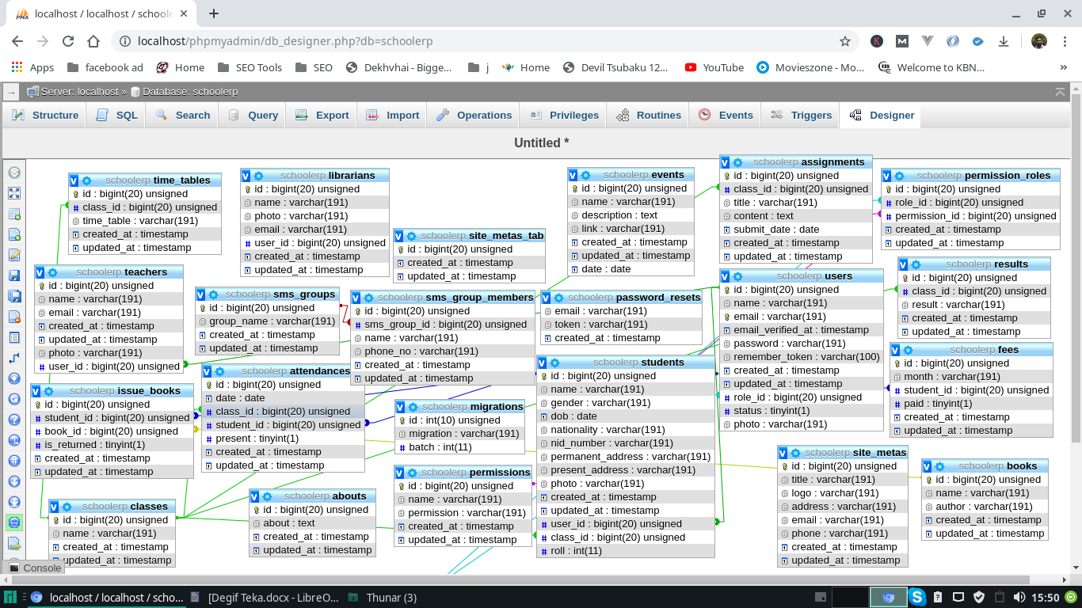

**Chapter 6**

**Implementation**

In this chapter, the tools used in developing the prototype and the developed system are described.

**6.1 Programming Tool**

PHP

For implementing the project, we are making use of php language as the main language. PHP is a server-side scripting language designed for web development but also used as a general-purpose programming language.PHP code can be embedded into HTML code, or it can be used in combination with various web template systems, web content management system and web frameworks.

JavaScript

JavaScript is a high-level, dynamic, untyped, and interpreted programming language.It has been standardized in the ECMAScript language specification.Alongside HTML and CSS, it is one of the three essential technologies of World Wide Web content production; the majority of websites employ it and it is supported by all modern Web browsers without plug-ins.

JavaScript is also used in environments that are not Web-based, such as PDF documents, site-specific browsers, and desktop widgets. Newer and faster JavaScript virtual machines (VMs) and platforms built upon them have also increased the popularity of JavaScript for server-side Web applications.

HTML/CSS

HyperText Markup Language, commonly referred to as HTML, is the standard markup lan-guage used to create web pages. Along with CSS, and JavaScript, HTML is a cornerstone technology used to create web pages, as well as to create user interfaces for mobile and web applications. Web browsers can read HTML files and render them into visible or audible web pages. HTML describes the structure of a website semantically and, before the advent of Cas-cading Style Sheets (CSS), included cues for the presentation or appearance of the document (web page), making it a markup language, rather than a programming language.

MySQL

MySQL is an open-source relational database management system (RDBMS) and the most widely used open-source clientâ“server model RDBMS.MySQL is a popular choice of database for use in web applications, and is a central component of the widely used LAMP open-source web application software stack (and other "AMP" stacks)

**Figures :**

**(Eikhane Screenshot kisu diyen monjurul vai)**

**Chapter 7**

**Conclusion and Recommendations**

**7.1 Conclusion**

In this project, we developed an automated school management system that facilitates the various activities taking place at schools.

The system developed in the project consists of windows and web applications. These are two different applications on the same database. The windows application takes most of the activities such as offline student registering, transcript and report card generation and producing the timetable. The web application facilitates attendance recording by the homeroom teachers and to view reports, to view status of students by students, teachers and parents.

Our solution of the timetabling problem is very simple. Data structures are used to implement the timetable designed. The scheduler selects a subject-teacher from the database, retrieves all the classes assigned to the teacher, calculates the load of the teacher which cannot be greater than the maximum load and selects one of the days randomly based on the number of lessons of the subject, searches a free appropriate time slot and assigns the slot to the lesson. The scheduler repeats the process until the load of the teacher becomes zero and all the teachers in the database are visited. Finally the result generated is stored in a database.

The prototype has been tested with data from Kokebe Tsebah Secondary School. It has been shown that the system effectively registers students along with parental information, easily retrieves information about a student and generates the required reports such as transcript, report card and timetable. In addition to generating a feasible master timetable it produces a timetable for each teacher. Further more it has been shown that the web application of the system helps attendance recording by the homeroom teacher and parents can view the status of their children using the Internet or Intranet of the school.

- 52 -

**7.2** **Recommendations**

To enhance the efficiency of the system, in the following we have listed some recommendations and future works.

As education is central to development there should be a good facility to make stakeholders participate in school improvement programs and decision making. Parents and Education Bureaus from Kebele and Kifle-ketema are among the stake holders. To facilitate easy information access to such bodies the web application could be further enhanced by incorporating additional reports required by Kebele and Kifle-ketema Education Bureaus. Such facilities will increase participants in decision making at educational activities and students achievement.

We also believe that timetables should be flexible. In real world situations there are preferences. A restriction of the sort that every teacher should have some specific free periods or some part of days off requires an efficient search technique. Efficiency of the timetable could be further enhanced by improving the search technique so that such constraints as preferences could be taken into consideration.

**References**